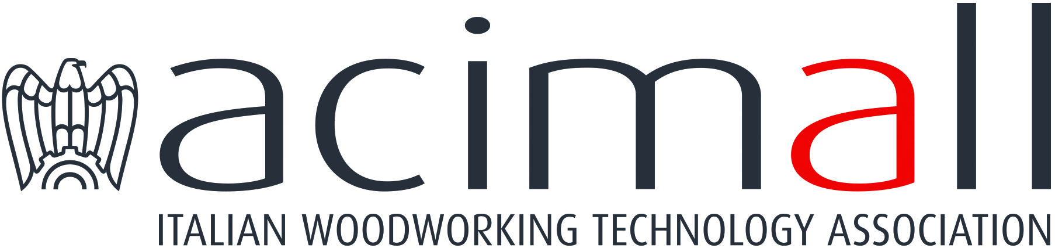 | Acimall  Centro Direzionale Milanofiori  Strada 1 - Palazzo F3  I-20090 Assago (Milano)  phone +39 02 89210200  fax +39 02 8259009  www.acimall.com  info@acimall.com | press office  17 February 2022

WOOD TECHNOLOGY: FOURTH QUARTER 2021 "EXTREMELY POSITIVE!"

The year 2021 showed that the pandemic emergency has also acted as a powerful driver for production in many industries. One of these is certainly the sector of machinery, plants, equipment and tools for wood and wood-based materials, which experienced a "stimulating" 2021 with a growth of orders that could hardly be imagined.

The October-December 2021 period was much "quieter" than the previous quarters, but still excellent: orders increased by 41 percent over the same period of 2020, resulting from a massive 60 percent growth on the domestic market and 38.6 percent increase on the international scenario. The other face of the coin is production, impacted by provisioning problems, price increases and delays in the supplies of raw materials and components, which might extend their effect well into the first part of the new year.

The quarterly survey by the Studies Office of Acimall (the association of Italian woodworking technology manufacturers) on a statistic sample of companies indicates that the orders book is equal to 6.1 months, a trend that had not been recorded for a long time.
Price variation in 2021 amounted to 5.2 percent.

The figures for the last quarter of the year offer a clear overview of 2021: according to the Acimall Studies office, the order intake in the 12-month period increased by 72 percent compared to 2020, when the impact of the pandemic was more devastating. This growth rate is nevertheless “significant”, also if compared with the orders collected in 2019 (plus 44.1 percent). If we compared “quarter-on-quarter” figures – i.e. October-December 2021 versus the same period in 2019 – orders increased by 46.1 percent, perfectly in line with the result recorded in 2021 on the whole.

More than positive results also for the quality survey, based on the answers of the interviewees, who indicated a positive trend (57 percent of the sample) or stationary (43 percent) trend of production. As you can see, no negative answers were given. Same trend for employment, which is expanding according to 57 percent of the sample and stable for 43 percent. Available stocks are stable according to 48 percent of the interviewees, increasing for 24 percent and decreasing for 28 percent.

Looking at the future, the forecast survey indicates a strong propensity to stability on foreign markets (76 percent of the sample), while 24 percent expect further growth in the first three months of this year. The domestic market will remain at the current level according to 66 percent of the interviewees, it will expand according to 29 percent and it will show signs of reduction according to 5 percent.

For more information:

Luca Rossetti

+39 351 9098189 - press@acimall.com

