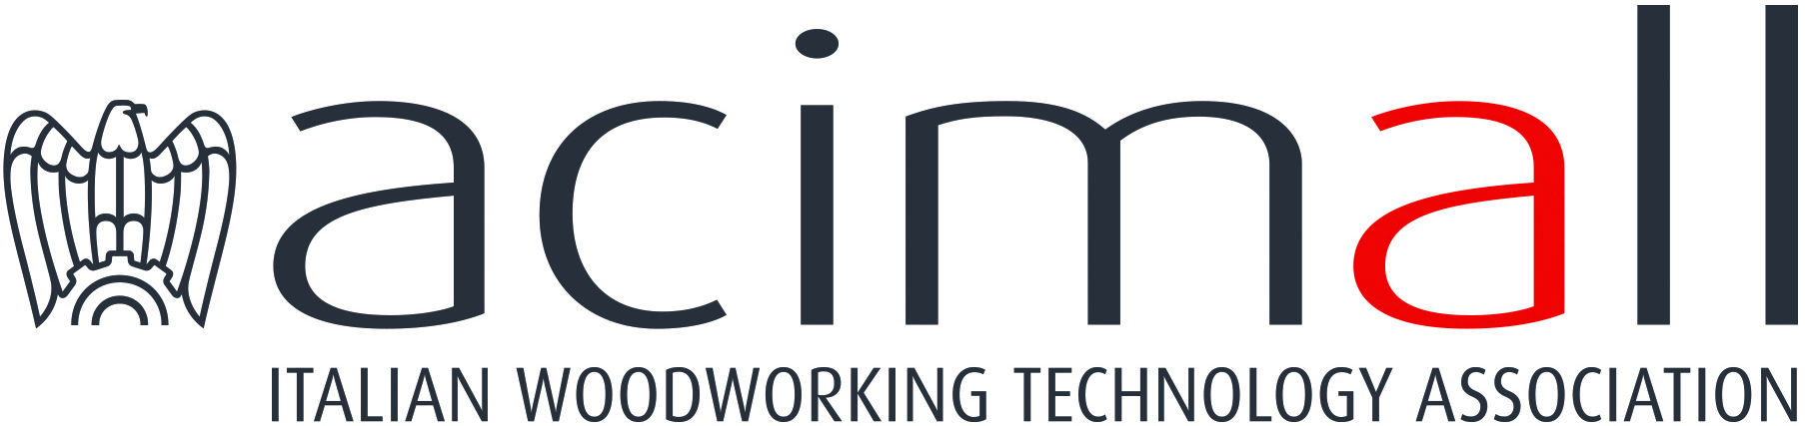 | Acimall  Centro Direzionale Milanofiori  Strada 1 - Palazzo F3  I-20090 Assago (Milano)  phone +39 02 89210200  fax +39 02 8259009  www.acimall.com  info@acimall.com | press office  31 May 2022

WOODWORKING TECHNOLOGY: STILL AN EXCELLENT Q1

The first quarter 2022, despite significant differences from the previous one, reaffirmed the good health conditions of the wood and furniture technology industry. This is the evidence of the quarterly survey made by the Studies office of Acimall - the Confindustria member association that gathers the Italian manufacturers of machines, tools and equipment - on a significant sample for the domestic production.
After closing 2021 with really extraordinary production figures (up by 36.9 percent compared to 2020 and 11.6 percent over 2019), the year that has just started seems well on the way to keep a positive trend.

In the January-March 2022 period, orders increased by 21.7 percent over the same quarter of 2021, as a result of 35.1 percent expansion on the domestic market – still showing high propensity to invest – and a moderate 3.3 percent growth recorded by export.

The orders book is stable at six months of secured production (6.1 months in the October-December 2021 period). Unfortunately, we are seeing a strong rally of prices, up by 5.3 percent in the first quarter 2022, continuing the trend recorded throughout last year.

“We are paying a high fee for the difficult situation of purchasing and supply chains”, said Luigi De Vito, president of Acimall. “The global economic and production system is facing a situation that has been worsened by the war in Eastern Europe, as well as the enduring uncertainty about possible pandemic developments in the second half of the year”. “Right now, it is still hard to say when we will go back to normal – De Vito concluded – and once again, our entrepreneurs will have to hold the rudder firmly, trying to navigate their companies in a situation where any prediction and decision appears to be difficult”.

The opinions collected by the quality survey are basically stable. 48 percent of the sample expects the positive trend of production to continue (versus 57 percent in the previous quarter); 52 percent expect substantial stability (43 percent in October-December 2021). Employment is on the rise according to 38 percent of the sample (versus 57 percent in the previous quarter), stable according to 62 percent (43 percent in October-December 2021). Stocks are stable according to 33 percent of the interviewees, increasing for 48 percent, decreasing for 19 percent.

Compared to the past, less optimism is emerging from the forecast survey: on foreign markets, 48 percent of the sample expects a period of stability (versus 76 percent in the previous quarter), 33 percent see further expansion (versus 24 percent), while 19 percent fear shrinkage. The domestic market will remain at the current level according to 43 percent of the interviewees (versus 66 percent in the previous survey), it will keep growing according to 33 percent (29 percent in the final quarter 2021), and it will decrease according to 24 percent (5 percent in October-December 2021).

For more information:

Luca Rossetti

+39 351 9098189 - press@acimall.com

